***INFORMATION REPORT***

**Contents:**

**1. Google Search Information……………………………… 3**

**2. Social Media………………………………………………. 4**

**3. General and Educational Information…………………… 6**

**4. Additional Information……………………………………. 7**

**5. Date of Birth, Age and Friends Information……………... 8**

**6. Certificates…………………………………………………..10**

**7. Twitter Account Information………………………………11**

**8. Resume Information………………………………...……...12**

**Findings:**

**Google Search Information:**

The first thing I have done for searching for profile is open the google page and searched by name: **Quentin berdugo,** it displays several results that are linked with other websites based on the subscription. I also found several personal images those are linked to your Facebook and other profiles.

**Screenshot for Proof:**

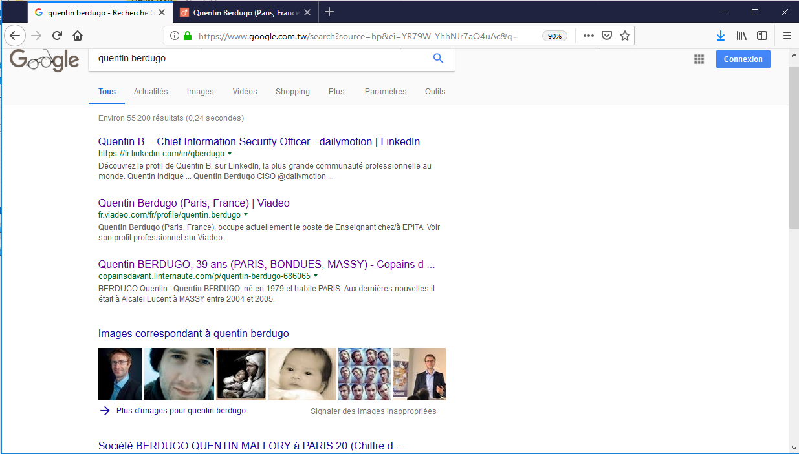

**Social Media:**

Social media is one of the best approaches for searching the personal information like Facebook and Linked in.

Unfortunately, I could not find more information on your Facebook profile, maybe only your Facebook users can access to your profile.

**Screenshot for Proof:**

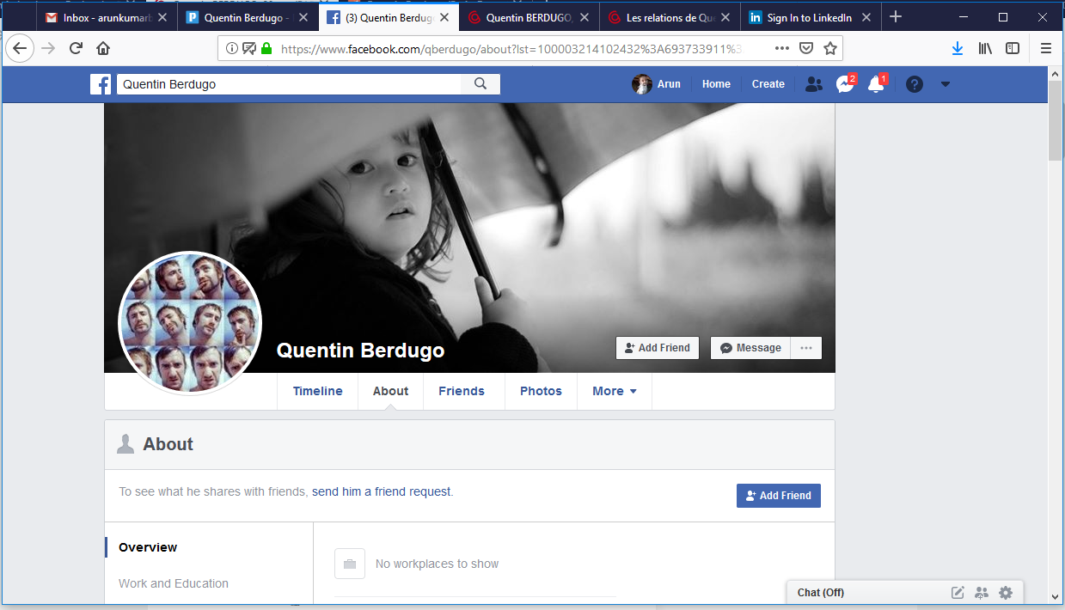

In Linked in, I found lot of information about your career in terms of schooling, experience and your present working role “**Chief Information Security Officer**”

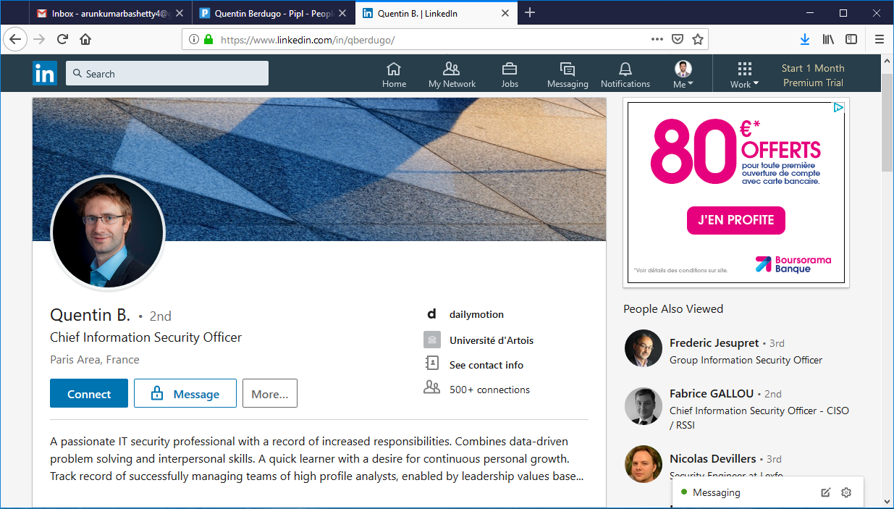

In this below page, you can see all the Experiences and present working position,

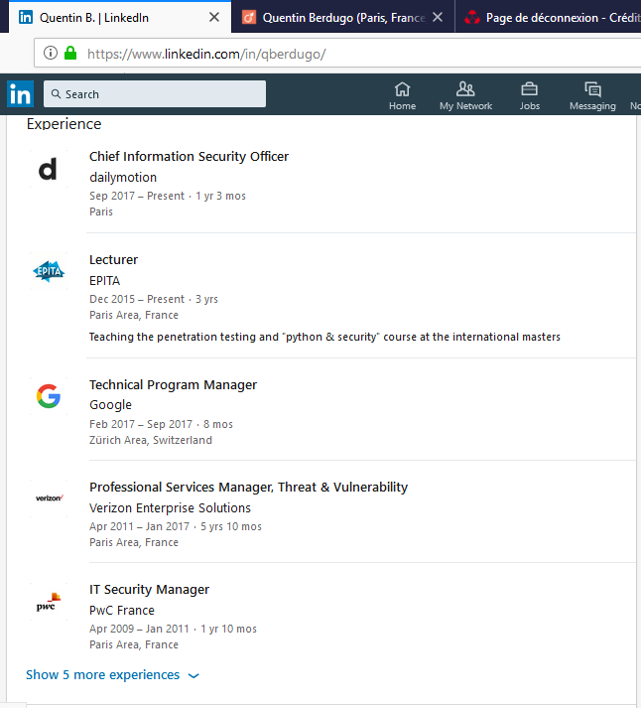

**General and Education Information:**

Using google page I went to 1st link, i.e, **pipl page,** it is showing the present working position and I found **USERNAME** and **ADDITIONAL NAME** and your location,

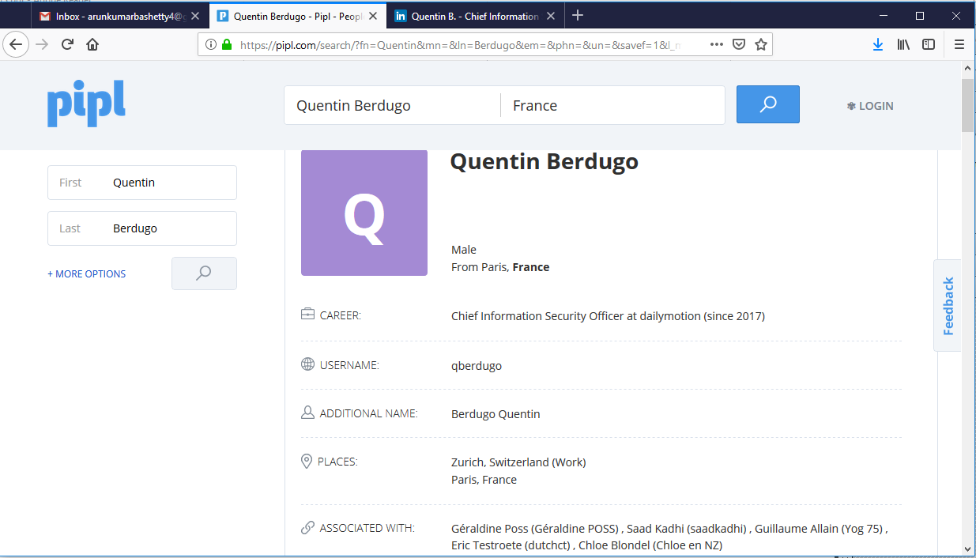

If I come to down the same page, it will be showing some links that are linked to your LinkedIn Profile and Other links those you are based on your subscription.

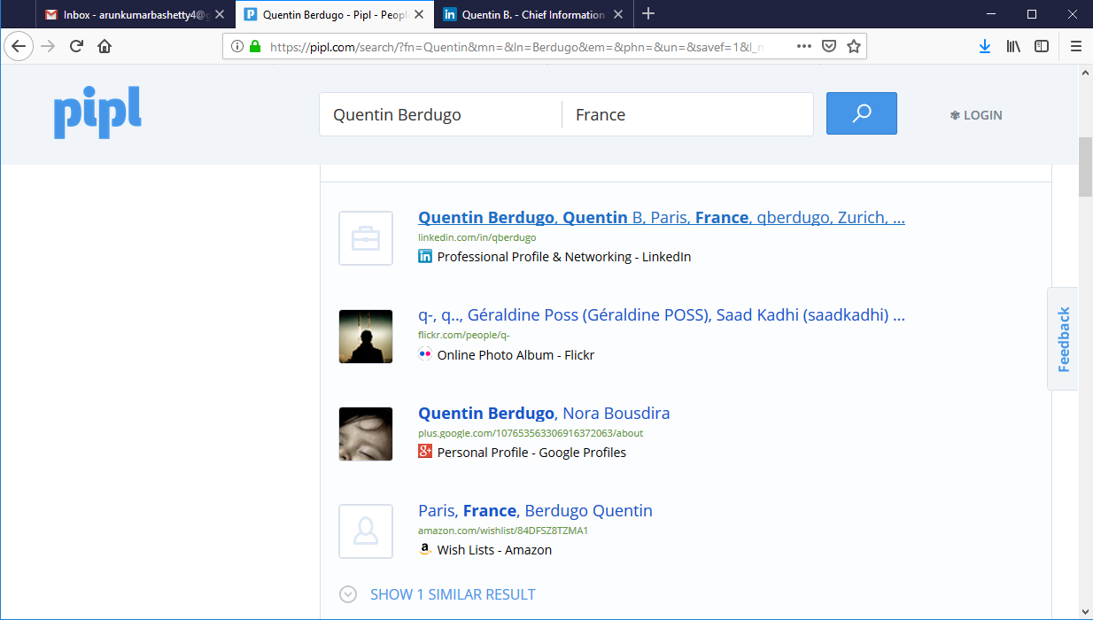

Additional Information:

In this below page, we can see the additional information that your home address, Formed juicier and SIREN,

and I found APE Number,

’

**Date of Birth, age and Friends Information:**

From google page, I used 3rd link, i.e., <http://copainsdavant.linternaute.com/p/quentin-berdugo-686065>

I found details of colleges you studied and your date of birth :**13-jul-1979** and your age.

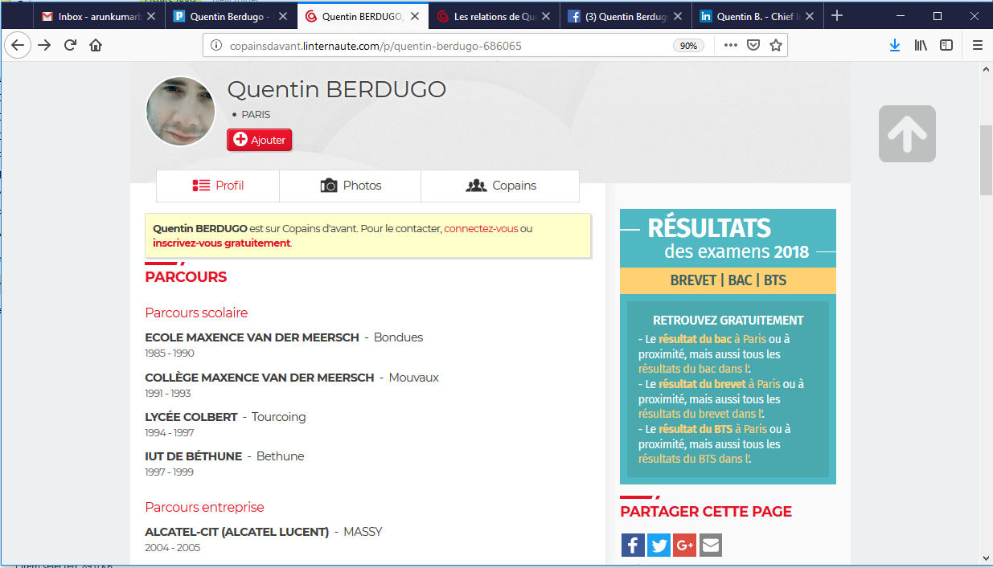

Here I found your friends list from **“Copainsdavant”** profile,

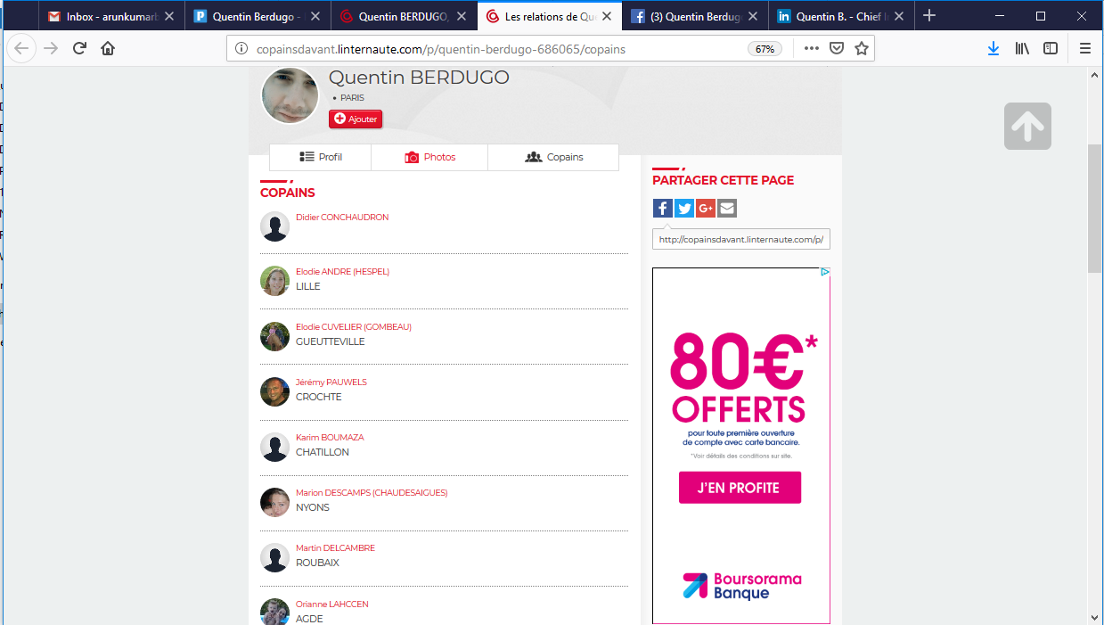

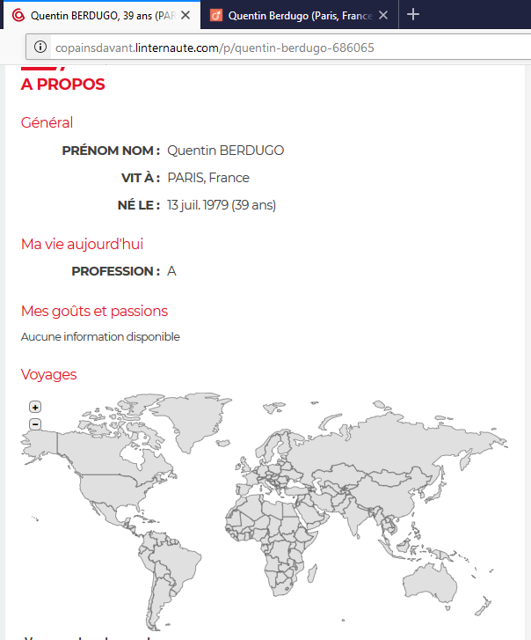

**Certificates:**

From [www.giac.org](http://www.giac.org) , I found the certified-Professional certificates, like **GREM, GWAPT, GPEN** and more certificates. Using **Slide Blast** through google.

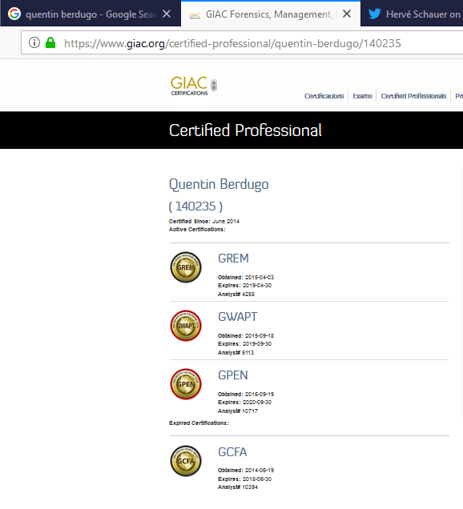

**Twitter Information:**

I found a recent and interest post from your Twitter account that the conference #vulnerability, there are too many reports not the one by which the incident happened and this post is posted by Herve Schauer(CEO of [~~@~~**HS2formation**](https://twitter.com/HS2formation))

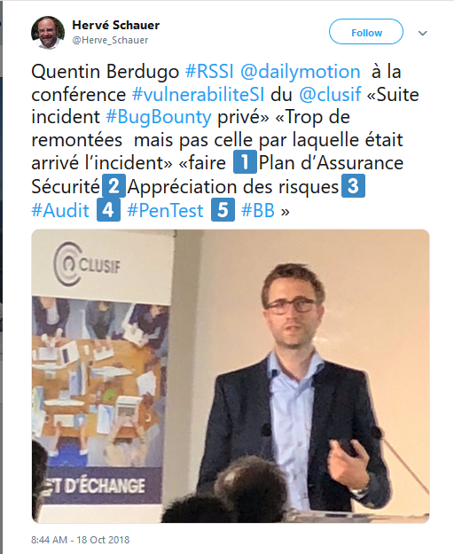

**Resume Information:**

Using the link: <http://fr.viadeo.com/fr/profile/quentin.berdugo>, I found the your profile which contain your resume and additional information and your laguages,

